SHRI BHAGUBHAI MAFATLAL POLYTECHNIC
AND COLLEGE OF ENGINEERING
PROGRAM: INFORMATION TECHNOLOGY
COURSE NAME: MACHINE LEARNING
COURSE CODE: MLP230910
SEMESTER: IV
TITLE: DIABETES AND HEART PREDICTION MODEL
PROJECT GUIDE: MRS. SWAPNA NAIK
STUDENT NAME: JANHAVI RAJU JAGADE
STUDENT ROLL NO: T041
SAP ID: 57498230045

ABSTRACT
Heart disease and diabetes are among the leading causes of mortality worldwide, necessitating early detection and prevention strategies. This project employs machine learning techniques to develop a predictive model for identifying individuals at risk of heart disease and diabetes using medical and lifestyle data. The model analyzes key independent variables such as age, blood pressure, glucose levels, BMI, cholesterol, and other relevant health indicators to assess the likelihood of developing these conditions. By identifying patterns and correlations within the dataset, the model provides valuable insights into the primary risk factors influencing heart disease and diabetes. The performance of the model is evaluated using accuracy, precision, recall, F1-score, and other relevant metrics to ensure reliability. The results from this analysis enable healthcare professionals to implement early interventions, optimize treatment plans, and improve patient outcomes.

SOFTWARE REQUIREMENTS
- PYTHON


Python is a general-purpose interpreted, interactive, object-oriented, and highlevel programming language. It was created by Guido van Rossum during 1985- 1990. Like Perl, Python source code is also available under the GNU General Public License (GPL). This tutorial gives enough understanding on Python programming language.
- JUPYTER

Google Colab (short for "Google Colaboratory") is a cloud-based Jupyter Notebook environment that allows users to write, execute, and share Python code online without requiring any setup. It is especially popular among machine learning (ML) and deep learning practitioners due to its free access to GPUs and TPUs.
Colab is widely used for education, research, and collaborative projects. It provides an easy-to-use interface, pre-installed libraries, and seamless integration with Google Drive and other cloud storage services.
HARDWARE REQUIREMENTS
- Operating System: Windows 11 or Windows 10 (64-bit recommended)
- Processor: Intel Core i7 10th Gen or equivalent, 2.00 GHz or higher
- Memory: 16 GB RAM or more (recommended for handling large datasets and model training)
- Storage: Minimum 500 GB of SSD storage for faster data processing and model performance
- Graphics: Dedicated GPU (NVIDIA GTX series or higher) for enhanced visualization and computational power (optional but recommended)
- Software: Python 3.10 or later, Streamlit, pandas, scikit-learn,
Matplotlib, Seaborn, and other essential ML libraries
BRIEF EXPLANATION OF MINI PROJECT
Heart disease and Diabetes are major global health concerns that affect millions of people, leading to severe complications if not detected early. Just as machine learning helps predict employee attrition by analyzing factors like job satisfaction and salary, it can also be used to predict the risk of heart disease and diabetes by examining key health parameters such as blood pressure, cholesterol levels, glucose levels, and BMI.
In this project, we developed a dual-prediction system using machine learning to assess the likelihood of an individual having heart disease or diabetes. We employed algorithms like Logistic Regression, Random Forest, SVM, and KNN, which are well-suited for binary classification tasks—similar to predicting whether an employee will stay or leave. The heart disease prediction model uses datasets like the UCI Cleveland Heart Disease dataset, while the diabetes prediction model relies on the Pima Indians Diabetes dataset. Before training the models, we performed data preprocessing (handling missing values, normalization) and exploratory data analysis (EDA), including correlation heatmaps to identify key risk factors—much like how attrition analysis examines factors influencing employee turnover.
The final system is deployed as a user-friendly web application (built with Flask or Streamlit), allowing doctors and patients to input health metrics and receive instant risk assessments. This tool can aid in early diagnosis, preventive care, and better healthcare decision-making—just as attrition prediction helps organizations implement retention strategies. Future enhancements could include integrating electronic health records (EHR) for real-time predictions and expanding the system to predict other conditions like hypertension, further improving its utility in clinical settings.

WHY WE CHOSE THIS TOPIC
Heart disease and diabetes are among the leading causes of death worldwide.Early prediction can save lives by enabling timely medical intervention.
Many cases go undetected until severe symptoms appear. A machine learningbased prediction system helps identify high-risk individuals before complications arise.
Hospitals, clinics, and even individuals can use this tool for early screening, reducing healthcare costs and improving patient outcomes.
Machine learning is revolutionizing healthcare. This project demonstrates how predictive analytics can assist doctors in decision-making.
Working on this project enhances data preprocessing, model training, and deployment skills, while also contributing to a socially impactful cause.

PROJECT SOURCE CODE:

Diabetes Model
# -*- coding: utf-8 -*-
"""DiabetesMLProject.ipynb

Automatically generated by Colab.

Original file is located at
https://colab.research.google.com/drive/14t3x8M7SU-4TSxf5ZnVFOfdxIRUXKJyK

# Importing Libraries
"""

# Commented out IPython magic to ensure Python compatibility.
import numpy as np
import pandas as pd
import matplotlib.pyplot as plt
from matplotlib import rcParams
from matplotlib.cm import rainbow
# %matplotlib inline
import warnings
warnings.filterwarnings('ignore')
import seaborn as sns
from sklearn.model_selection import train_test_split
from sklearn.preprocessing import StandardScaler
from sklearn.metrics import accuracy_score
from sklearn.metrics import classification_report
from sklearn import *
from sklearn.neighbors import KNeighborsClassifier
from sklearn.svm import SVC
from sklearn.tree import DecisionTreeClassifier
from sklearn.linear_model import LogisticRegression

"""# Load Dataset"""

diabetes_dataset = pd.read_csv('/content/diabetes.csv')
diabetes_dataset

diabetes_dataset.head()

diabetes_dataset.tail()

diabetes_dataset.info()

diabetes_dataset.describe()

diabetes_dataset.shape

diabetes_dataset.isnull().sum()

diabetes_dataset.nunique()

diabetes_dataset['Outcome'].value_counts()

diabetes_dataset.groupby('Outcome').mean()

X = diabetes_dataset.drop(columns='Outcome', axis=1)
Y = diabetes_dataset['Outcome']

X

Y

scaler = StandardScaler()
scaler.fit(X)

Standardized_data = scaler.transform(X)
Standardized_data

X = Standardized_data
Y = diabetes_dataset['Outcome']

X

Y

"""# Train Test Split"""

X_train, X_test, Y_train, Y_test = train_test_split(X, Y, test_size=0.2,stratify=Y, random_state=2)
print(X.shape, X_train.shape, X_test.shape)

classifier = svm.SVC(kernel='linear')
classifier.fit(X_train,Y_train)

X_train_prediction = classifier.predict(X_train)
training_data_accuracy = accuracy_score(X_train_prediction, Y_train)

print('Accuracy of training data: ',training_data_accuracy)

X_test_prediction = classifier.predict(X_test)
testing_data_accuracy = accuracy_score(X_test_prediction, Y_test)
print('Accuracy of testing data: ',testing_data_accuracy)

"""# Predictive System"""

input_data = np.array([1,85,66,29,0,26.6,0.351,31])

input_data_reshaped = input_data.reshape(1,-1)

std_data = scaler.transform(input_data_reshaped)

prediction = classifier.predict(std_data)
print(prediction)

if prediction[0] == 0:
print("Low risk of Diabetes")
else:
print("High risk of Diabetes")

import pickle

filename = 'Diabetes_model.sav'
with open(filename, 'wb') as file:
pickle.dump(classifier, file)

loaded_model = pickle.load(open('Diabetes_model.sav','rb'))

with open("scaler.sav", "wb") as f:
pickle.dump(scaler, f)

Heart Disease Model
# -*- coding: utf-8 -*-
"""HeartMLProject.ipynb

Automatically generated by Colab.

Original file is located at
https://colab.research.google.com/drive/1hzXMagNtvrdStnjoQ07ojU59EKssdVEG

# Importing Libraries
"""

# Commented out IPython magic to ensure Python compatibility.
import numpy as np
import pandas as pd
import matplotlib.pyplot as plt
from matplotlib import rcParams
from matplotlib.cm import rainbow
# %matplotlib inline
import warnings
warnings.filterwarnings('ignore')
import seaborn as sns
from sklearn.model_selection import train_test_split
from sklearn.preprocessing import StandardScaler
from sklearn.metrics import accuracy_score
from sklearn.metrics import classification_report
from sklearn import *
from sklearn.neighbors import KNeighborsClassifier
from sklearn.svm import SVC
from sklearn.tree import DecisionTreeClassifier
from sklearn.linear_model import LogisticRegression

"""# Read Data and Preprocess"""

heart_data = pd.read_csv('/content/heart.csv')
heart_data

heart_data.head()

heart_data.tail()

heart_data.describe()

heart_data.info()

heart_data.shape

heart_data.isnull().sum()

heart_data.nunique()

corr = heart_data.corr()
corr.style.background_gradient(cmap='coolwarm')

sns.histplot(heart_data['age'], bins=20, kde=True, color='blue')
plt.title("Age Distribution")
plt.show()

sns.countplot(x=heart_data['target'], palette="Set1")
plt.title("Distribution of Heart Disease")
plt.show()

plt.figure(figsize=(10, 6))
sns.heatmap(heart_data.corr(), annot=True, cmap="coolwarm", fmt=".2f")
plt.title("Feature Correlation Heatmap")
plt.show()

heart_data['target'].value_counts()

X = heart_data.drop(columns='target', axis=1)
Y = heart_data['target']

print(X)

print(Y)

"""# Train Test Split"""

X_train, X_test, Y_train, Y_test = train_test_split(X, Y, test_size=0.2,stratify=Y, random_state=2)
print(X.shape, X_train.shape, X_test.shape)

"""# Logistic Regression"""

model = LogisticRegression()
model.fit(X_train, Y_train)

"""# Model Evaluation"""

X_train_prediction = model.predict(X_train)
training_data_accuracy = accuracy_score(X_train_prediction, Y_train)
print('Accuracy of training data: ',training_data_accuracy)

X_test_prediction = model.predict(X_test)
testing_data_accuracy = accuracy_score(X_test_prediction, Y_test)
print('Accuracy of testing data: ',testing_data_accuracy)

"""# Building a prediction system"""

input_data = np.array([71, 0, 0, 112, 149, 0, 1, 125, 0, 1.6, 1, 0, 2])

input_data_reshaped = input_data.reshape(1,-1)
prediction = model.predict(input_data_reshaped)
print(prediction)

if prediction[0] == 0:
print("Low risk of Heart Disease")
else:
print("High risk of Heart Disease")

import pickle

filename = 'HeartDisease_model.sav'
with open(filename, 'wb') as file:
pickle.dump(model, file)

loaded_model = pickle.load(open('HeartDisease_model.sav','rb'))

Streamlit .py file
#!/usr/bin/env python3
# -*- coding: utf-8 -*-
"""
Created on Sun Mar 30 20:12:45 2025

@author: vinayakchivilkar
"""

import pickle
import streamlit as st
from streamlit_option_menu import option_menu
import numpy as np

#loading the saved models

diabetes_model = pickle.load(open('/Users/vinayakchivilkar/Desktop/College/SEM 4/ML_Project/Diabetes_model.sav','rb'))
scaler = pickle.load(open('/Users/vinayakchivilkar/Desktop/College/SEM 4/ML_Project/scaler.sav', 'rb'))

heart_disease_model = pickle.load(open('/Users/vinayakchivilkar/Desktop/College/SEM 4/ML_Project/HeartDisease_model.sav','rb'))

#sidebar
with st.sidebar:

selected = option_menu('Multiple Disease Prediction System',
['Diabetes Prediction',
'Heart Disease Prediction'],
icons = ['activity',
'heart'],
default_index = 0)

if (selected == 'Diabetes Prediction'):

st.title('Diabetes Prediction using ML')

col1, col2, col3 = st.columns(3)

with col1:
Pregnancies = st.text_input('Number of Pregnancies')

with col2:
Glucose = st.text_input('Glucose level')

with col3:
BloodPressure = st.text_input('Blood Pressure value')

with col1:
SkinThickness = st.text_input('Skin Thickness value')

with col2:
Insulin = st.text_input('Insulin level')

with col3:
BMI = st.text_input('BMI Value')

with col1:
DiabetesPedigreeFunction = st.text_input('Diabetes Pedigree Function Value')

with col2:
Age = st.text_input('Age of the person')

#code for prediction
diab_diagnosis = ''

#button for Prediction

if st.button('Diabetes Test Result'):

input_data = np.array([
float(Pregnancies), float(Glucose), float(BloodPressure),
float(SkinThickness), float(Insulin), float(BMI),
float(DiabetesPedigreeFunction), float(Age)
]).reshape(1, -1)

input_data_scaled = scaler.transform(input_data)

diab_prediction = diabetes_model.predict(input_data_scaled)
if (diab_prediction[0]==1):
diab_diagnosis = 'High risk of Diabetes'
else:
diab_diagnosis = 'Low risk of Diabetes'

st.success(diab_diagnosis)

if (selected == 'Heart Disease Prediction'):
st.title('Heart Disease Prediction using ML')

col1, col2, col3 = st.columns(3)

with col1:
Age = st.text_input('Age of the Person')

with col2:
Sex = st.text_input('Gender')

with col3:
cp = st.text_input('Chest Pain Types')

with col1:
trestbps = st.text_input('Resting Blood Pressure')

with col2:
chol = st.text_input('Serum Cholestrol in mg/dl')

with col3:
fbs = st.text_input('Fasting Blood Sugar')

with col1:
restecg = st.text_input('Resting Electrocardiographic results (values 0,1,2)')

with col2:
thalach = st.text_input('Maximum Heart Rate achieved')

with col3:
exang = st.text_input('Exercise Induced Angina')

with col1:
oldpeak = st.text_input('ST depression induced by exercise')

with col2:
slope = st.text_input('Slope of the peak exercise ST segment')

with col3:
ca = st.text_input('Major vessels colored by flourosopy')

with col1:
thal = st.text_input('thal: 0 = normal; 1 = fixed defect; 2 = reversable defect')

#code for prediction
heart_diagnosis = ''

#button for Prediction
if st.button('Heart Disease Test Result'):
input_data = np.array([Age, Sex, cp, trestbps, chol, fbs, restecg, thalach, exang, oldpeak, slope, ca, thal], dtype=float)
heart_prediction = heart_disease_model.predict([input_data])

if (heart_prediction[0]==1):
heart_diagnosis = 'High risk of Heart Disease'
else:
heart_diagnosis = 'Low risk of Heart Disease'

st.success(heart_diagnosis)

OUTPUT
Dataset:
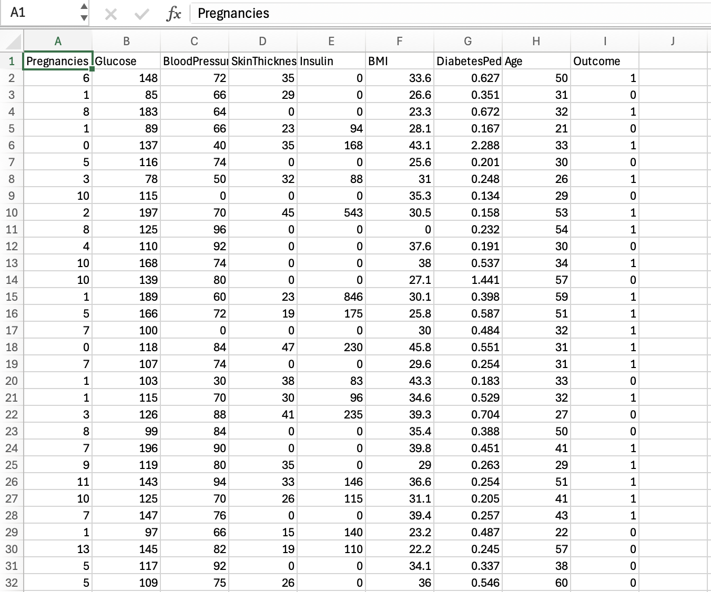

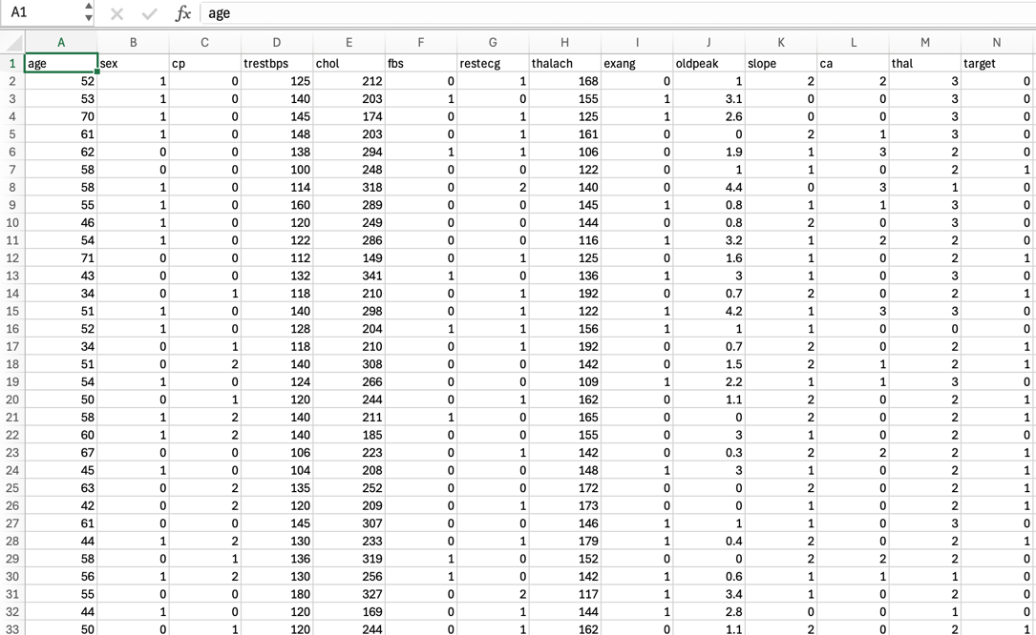
User Input Frame:
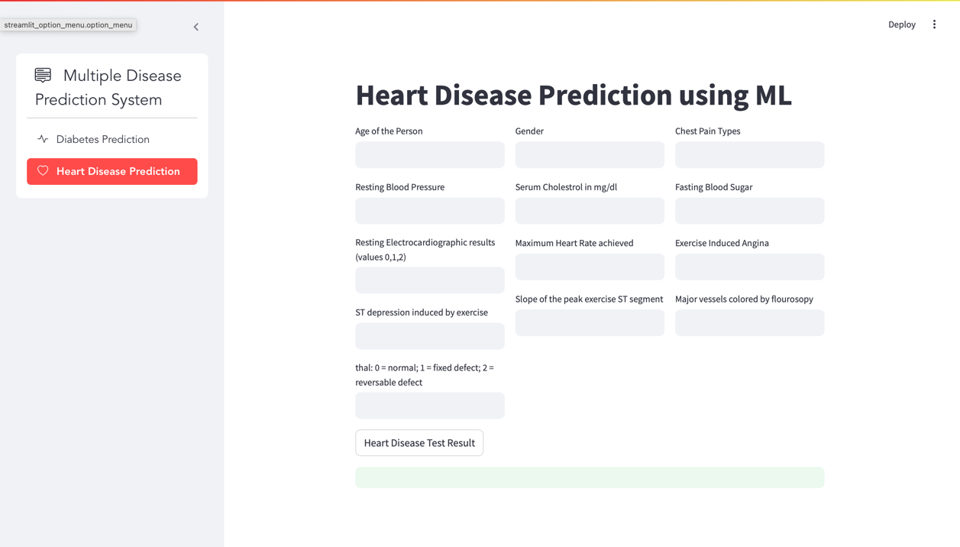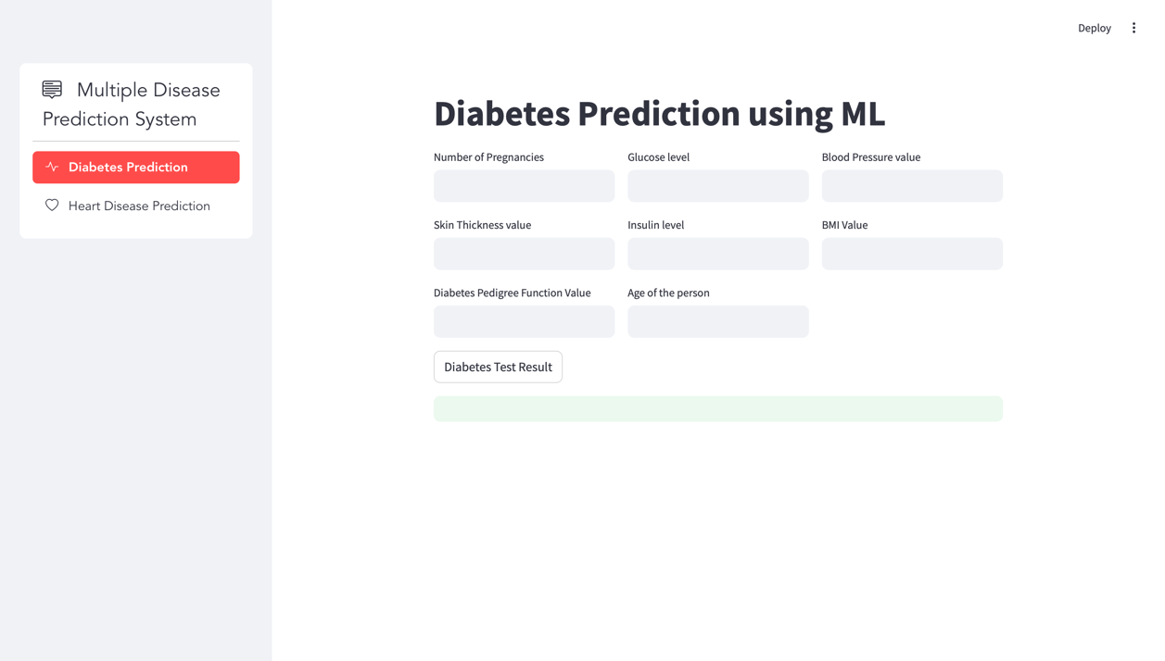

Graphs:
Diabetes model:

Correlation:
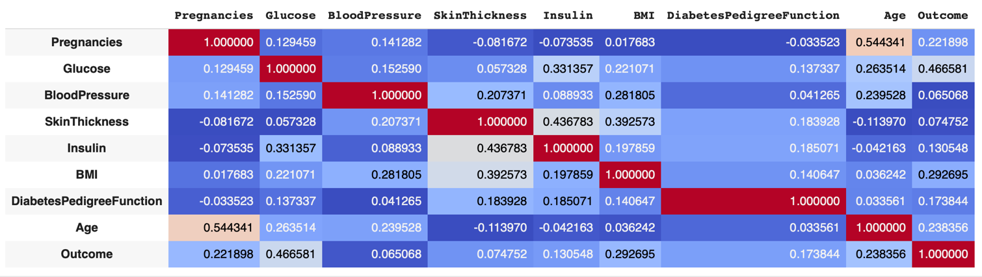

Histogram:
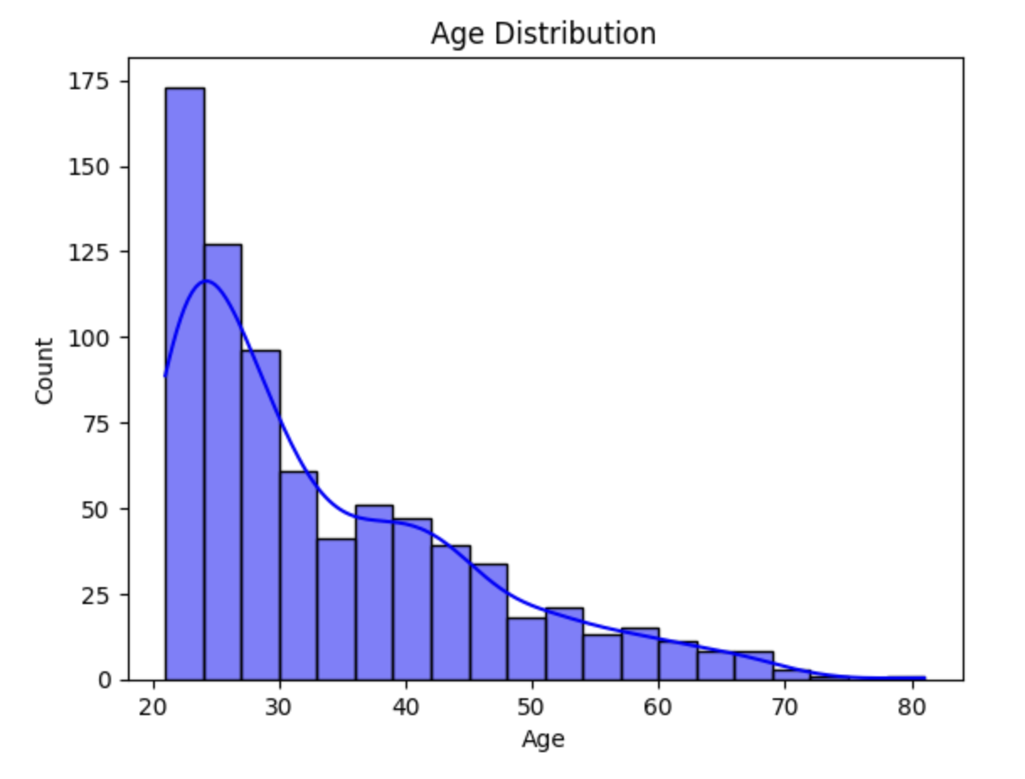
Count Plot:
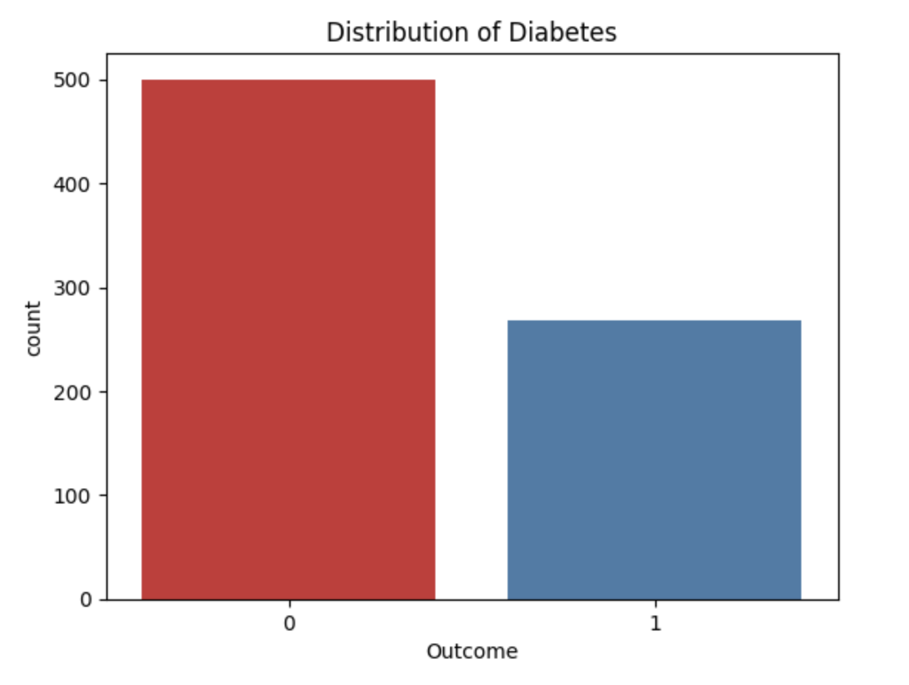
Heat Map: 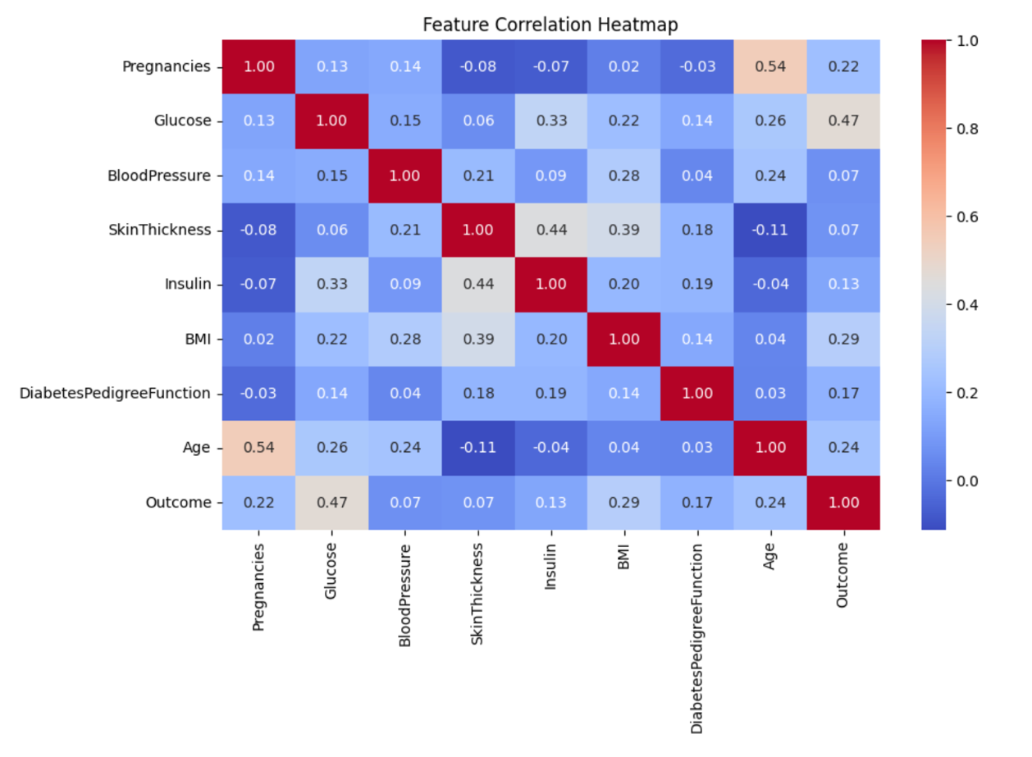
Heart Disease Model:
Correlation:
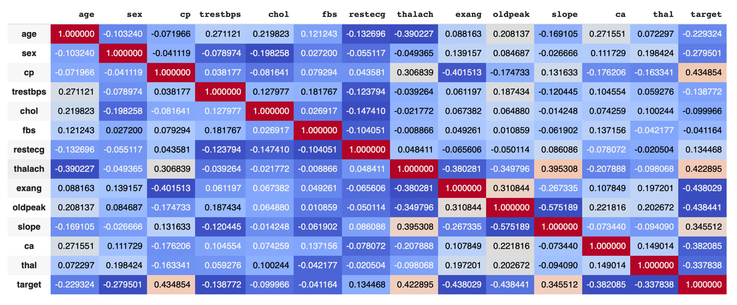

Histogram:
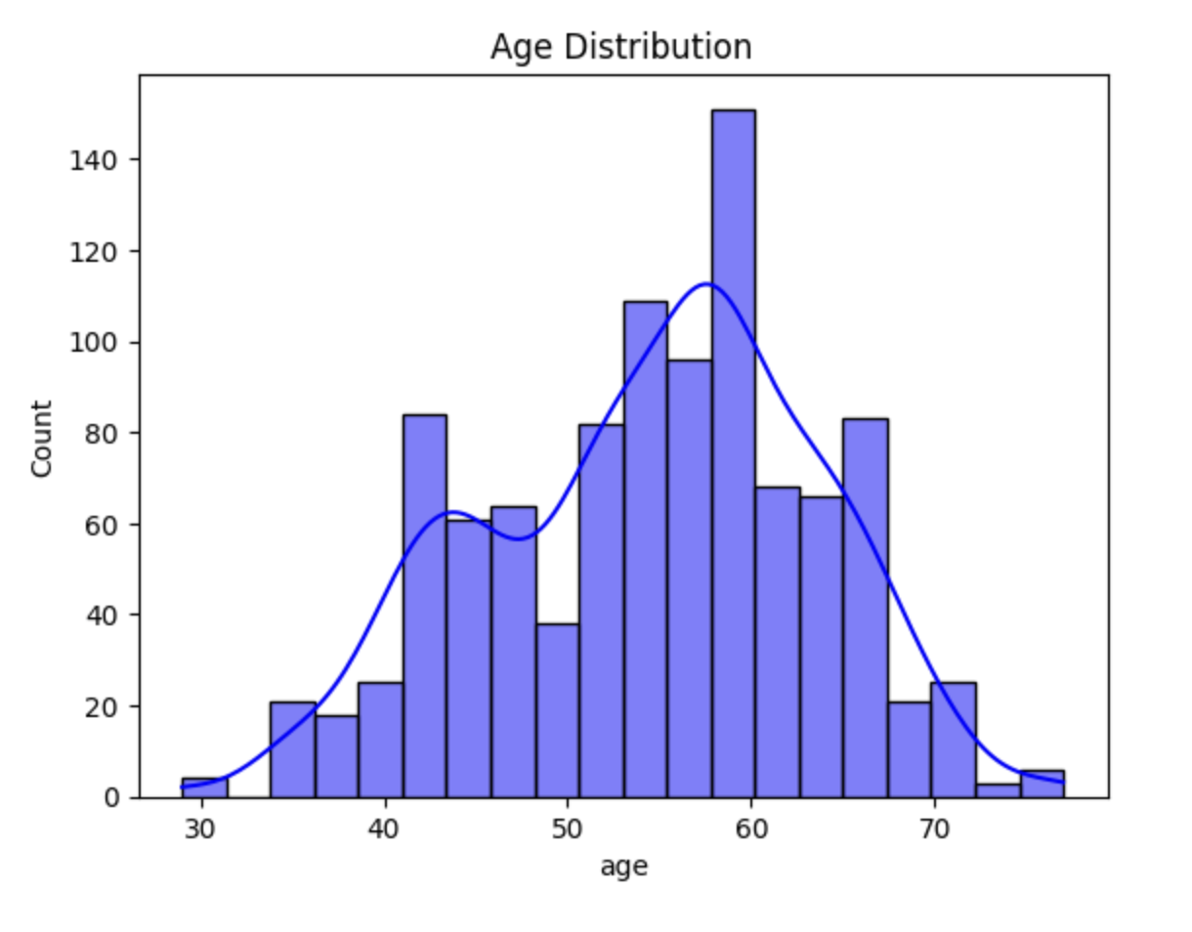
Count Plot:
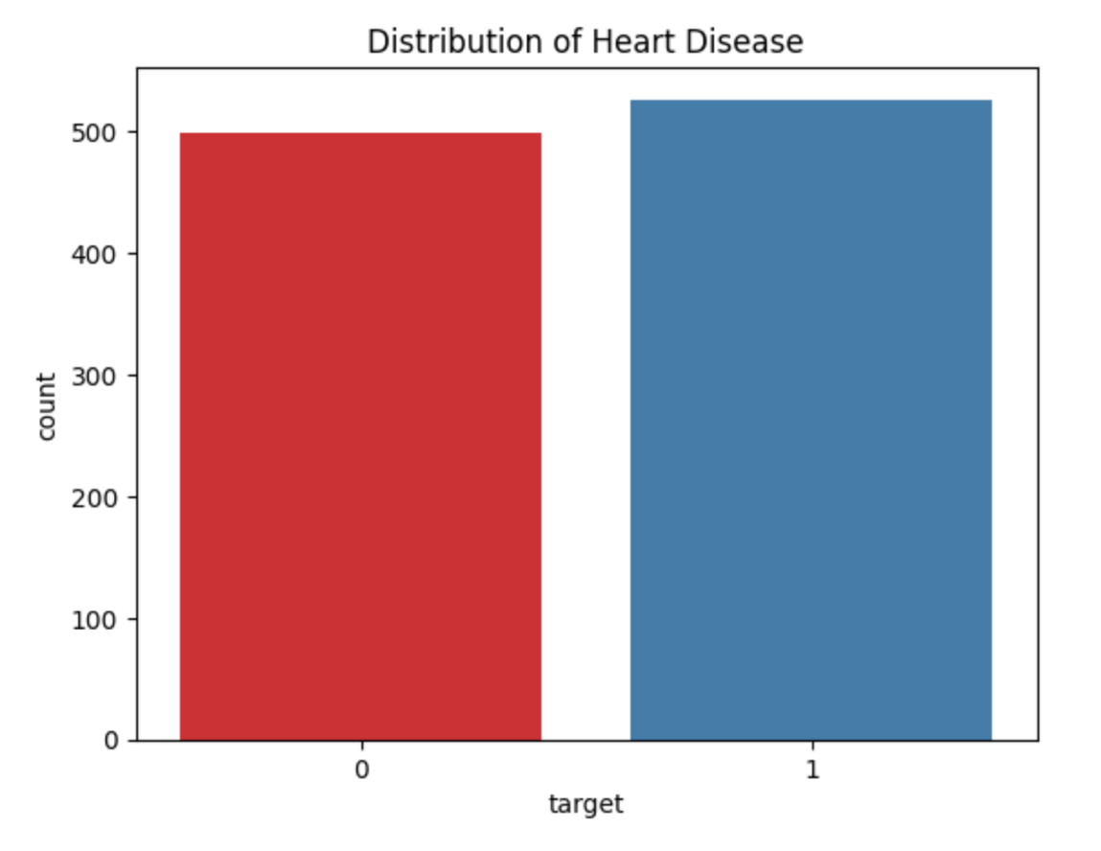
Heatmap:

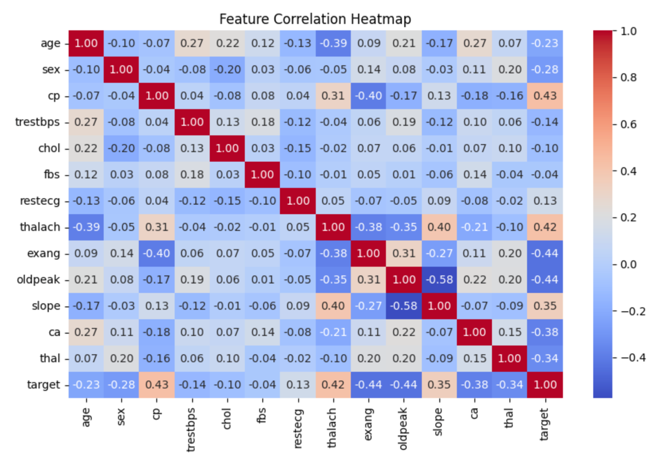

CONCLUSION
Heart disease and diabetes are critical global health challenges that require early detection and preventive measures. By leveraging machine learning, this project successfully developed a predictive system to assess an individual’s risk of these conditions based on key health parameters. Using algorithms like Logistic Regression, Random Forest, and SVM, we created an accurate and reliable model that can assist healthcare professionals in making data-driven decisions.
The project not only highlights the power of AI in modern healthcare but also demonstrates how technology can bridge gaps in early diagnosis and patient care. With further enhancements, such as integration with electronic health records (EHR) and expansion to other diseases, this system can become an invaluable tool for doctors, hospitals, and even personal health monitoring.
Ultimately, this work contributes to the growing field of predictive healthcare, empowering both medical professionals and individuals to take proactive steps toward better health outcomes. By combining data science and medicine, we move closer to a future where life-threatening diseases can be detected and managed before they escalate.

